A339-Asia-Cambodia-Bodhisattva, pre-Angkor Period, Phnom da style-Sandstone-7th century CE

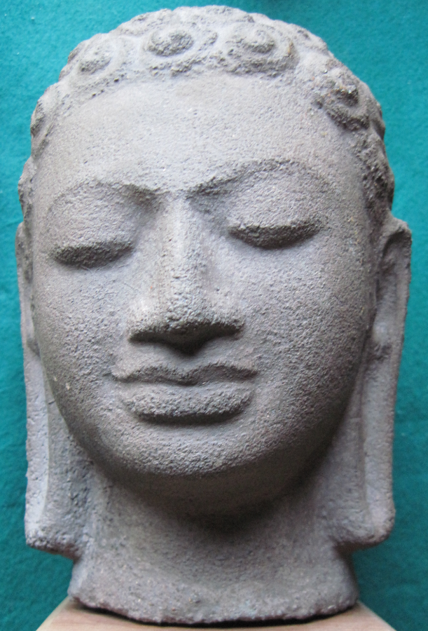 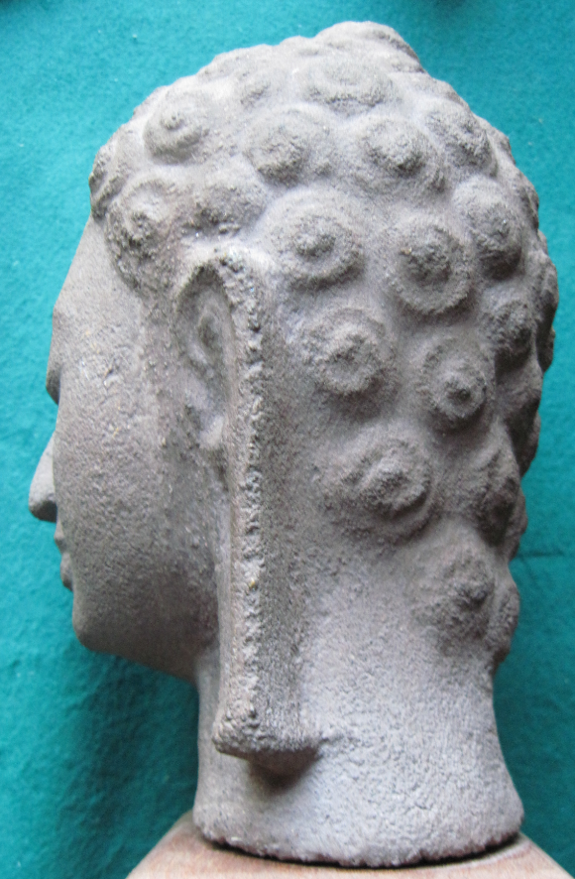 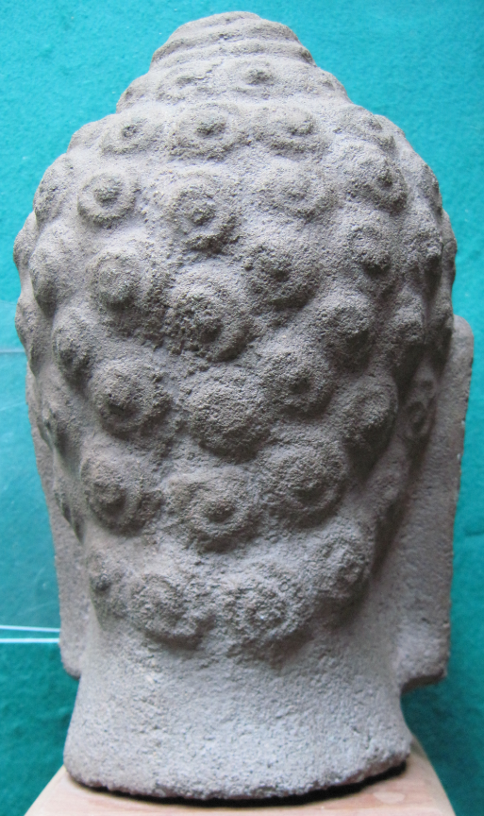

Figs. 1-3. Cambodia-Bodhisattva, pre-Angkor Period, Phnom da style-Sandstone-7th century CE

**Case no.: 3**

**Accession Number: A339**

**Formal Label:** Cambodia-Bodhisattva, pre-Angkor Period, Phnom da style-Sandstone-7th century CE

**Display Description:**

The oldest known Khmer stone sculptures date to the early 7th century, which is 100 years later than the traditional dating by Coédes (1953; see Dowling 1999). Phnom Da sculptures had an elegant form and refined detail similar to Indian Gupta art with a delicate anatomical balance between abstraction and linear details as in this bust of a Bodhisattva. Phnom Da near Angkor Borei in the Mekong Delta, was the capital of the Funan Civilization, which was dominant in the area of present-day Cambodia and southern Vietnam from the 2nd to the middle of the 7th centuries CE.

**LC Classification:** N7315

**Date or Time Horizon:** 7th century CE

**Geographical Area:** Phnom Da, Cambodia

**Map, GPS coordinates:** 10.96360 104.98719;40° 26' 46" N 79° 58' 56" W.

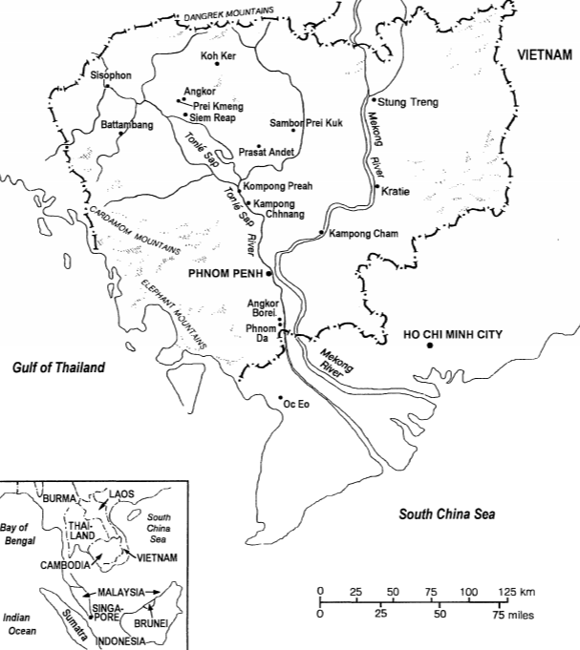

Fig. 4. Map of 7th century CE Cambodia after Dowling (1999 Fig. 1).

**Cultural Affiliation:** Phnom Da, 7th century CE

**Medium:** sandstone

**Dimensions:** 188.56 mm; 7.42 in

**Weight: 1822 gm; 4 lb 1/4 oz.**

**Condition: Phnom Penh Museum replica**

**Provenance:** **Phnom Penh Museum**

**Discussion:**

**“**New artistic evidence supports a mid-seventh-century date on which a new chronology for early Cambodian sculpture can be established.” **“**The Phnom Da images indicate that ‘the strategy of monumental validation’ first appeared in the early to mid-seventh century, after the dismemberment of Funan by Chenla. Only then does the artistic evidence suggest that local rulers seriously began to adopt Indian practices and beliefs that were to characterize Southeast Asia for the next 1000 years.”“By assigning a mid-seventh-century date to the earliest known Cambodian sculpture, the Phnom Da images do not exist in an artistic vacuum. These images are now inseparable from a widespread artistic development in seventh-century Cambodia, when permanent materials first appear in temple architecture and sculpture. The Vat Chumpon inscription from Surin (K. 377) eulogizes the installation of "an image of Nandin in stone" by Citrasena-Mahendravarman, who reigned between A.D. 598 and sometime before A.D. 617 (Coedès 1953: 3-4).” (Dowling 1999: 61).

**References:**

Dowling, Nancy.1999. “A New Date for the Phnom Da Images and Its Implications for Early Cambodia,” *Asian Perspectives*, 38(1): 51-61.

Coedès, George. 1953. “Inscriptions du Cambodge,” Paris: E. ,de Bocard, Vol. 5.